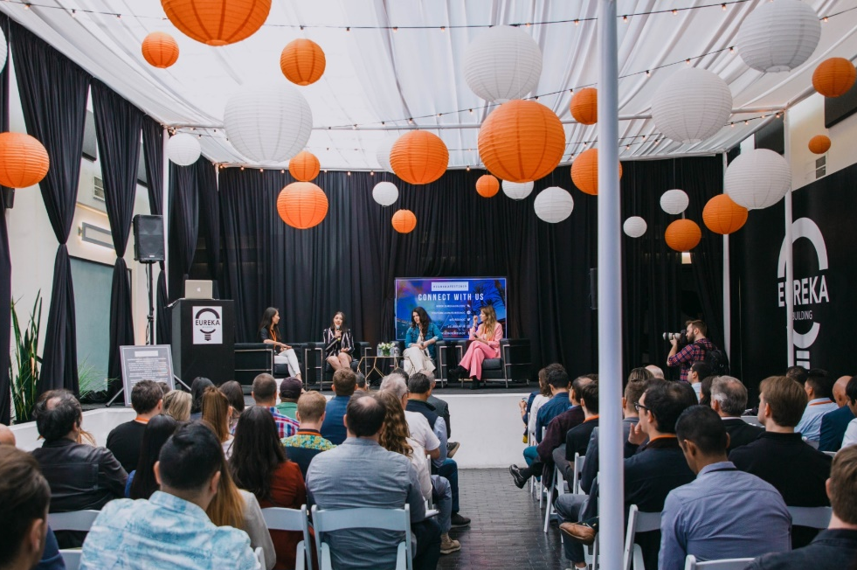
Press Release
Contact:
Samantha Misurell / Eureka Building
1621 Alton Parkway
Irvine CA, 92606
949-220-6500
samantha@eurekahub.com

Release Date:
3/10/2022

EUREKA BUILDING PRESENTS EUREKA FEST 2022: FIND THE FUTURE
The anticipated Southern California tech + start up festival is back with its sights set on the future.
Orange County, CA –Eureka FEST 2022: Find the Future, powered by COX Business is taking place at the Eureka Building at 1621 Alton Parkway Irvine CA 92606 on April 29 – 30th 2022 featuring a job fair presented by UCI Paul Merage School of Business, demo tables, pitch contest, keynote speakers, workshops, and networking opportunities.
FEST celebrates entrepreneurship through innovative content with distinguished speakers, pitch contest, start-up demos and live music. FEST attendees can hear from a lineup of experts, network with industry influencers and most importantly - have a good time and get inspired! Each year FEST brings together more than 600+ entrepreneurs, technology leaders, startup CEOs, investors, city officials, university faculty, developers, and more to celebrate OC’s growing startup and tech scene.
Past speakers include Billy Zane, Actor + CEO, The Convergence Lab, Kelly Vlahakis-Hank, President + CEO, Earth Friendly Products (ECOS) and Domenic Perri, Director of Business Development, Dropbox.
“Some of the Ways the Eureka FEST is making an impact are simply providing practical knowledge, tool sets, access, opportunity to networking,” Bill Zane, Actor + CEO, The Convergence Lab.
Eureka Building is currently taking applications for Demo Tables Slots, Job Fair Tables, and Pitch Contest participants on their website: www.eurekafest.com
Established in 2014, the Eureka Building is a 3-acre creative office, coworking and event campus in Irvine designed to offer Orange County’s startups a community, accelerate innovation and support local entrepreneurship. Through events such as Eureka FEST 2022, Eureka Building puts Irvine, CA on the map as a valuable channel for increased tourism and commerce, which benefits the entire tech community.
For Eureka FEST 2022 schedule and registration, please view: www.eurekafest.com
###

